Date:11.11.2022

**Final Year B. Tech., Sem VII 2022-23**

**Cryptography And Network Security Lab**

**Assignment submission**

**PRN : 2019BTECS00071**

**Name : Charpale Abhishek**

**Batch: B3**

**Assignment: 10**

**Assignment 10: Implementation of Chinese Remainder Theorem**

**Title:**

Implementation of Chinese Remainder Theorem

**Aim:**

To develop and implement the Chinese Remainder Theorem

**Theory:**

* In mathematics, the Chinese remainder theorem states that if one knows the remainders of the Euclidean division of an integer n by several integers, then one can determine uniquely the remainder of the division of n by the product of these integers, under the condition that the divisors are pairwise coprime
* For example, if we know that the remainder of n divided by 3 is 2, the remainder of n divided by 5 is 3, and the remainder of n divided by 7 is 2, then without knowing the value of n, we can determine that the remainder of n divided by 105 (the product of 3, 5, and 7) is 23. Importantly, this tells us that if n is a natural number less than 105, then 23 is the only possible value of n.
* The Chinese remainder theorem is widely used for computing with large integers, as it allows replacing a computation for which one knows a bound on the size of the result by several similar computations on small integers.

**Implementation of Chinese Remainder Theorem**

**Code:**

#include<bits/stdc++.h>

using namespace std;

// returns x where (a * x) % b == 1

int mul_inv(int a, int b)

{

int b0 = b, t, q;

int x0 = 0, x1 = 1;

if (b == 1) return 1;

while (a > 1) {

q = a / b;

t = b, b = a % b, a = t;

t = x0, x0 = x1 - q * x0, x1 = t;

}

if (x1 < 0) x1 += b0;

return x1;

}

int chinese_remainder(int *n, int *a, int len)

{

int p, i, prod = 1, sum = 0;

for (i = 0; i < len; i++)

prod *= n[i];

cout<<"The Product of Divisors is: "<<prod<<endl;

for (i = 0; i < len; i++) {

p = prod / n[i];

sum += a[i] * mul_inv(p, n[i]) * p;

}

return sum % prod;

}

int main(void)

{

int n[] = { 3, 5, 7 };

int r[] = { 2, 3, 2 };

cout<<"The Divisors are: ";

for(int i = 0;i < 3;i++)

cout<<n[i]<<" ";

cout<<"and their respective remainder are: ";

for(int i = 0;i < 3;i++)

cout<<r[i]<<" ";

cout<<endl;

int ans = chinese_remainder(n, r, sizeof(n)/sizeof(n[0]));

cout<<"Output: "<<ans<<endl;

return 0;

}

**Output:**

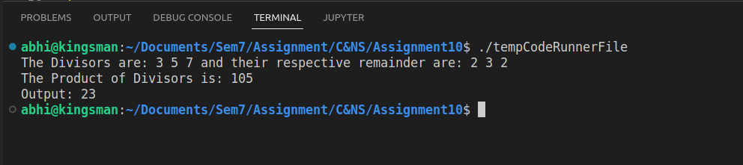

**Conclusion:**

Performed the experiment successfully.

The Chinese remainder theorem can be used to get the primitive number of the large Prime numbers